Title: The path to the “Final Solution”
Authors: Denise Walter Xavier (Portugal) and Maria Teresa Castelló Bou, Catalonia (Spain)
Pedagogical advisor: Loranda Miletić
Allocated total time of the LA: 2 hours (2X 55 minutes)
Target group (age indication and place in the curriculum):

Country | Portugal | Spain/Catalonia
Age indication | 15-17 years-old students | 15-16-year-old students (4th of ESO)
Place in the curriculum | History  Curriculum for History,  secondary education:  12th (History A); 11th (History B); 12th (History, Cultures and Citizenship) | History  Curriculum for History established by the Department of Education of Generalitat de Catalunya

Teaching aims (What do we intend to achieve by this learning activity?):
Using a variety of historical sources and models of collaborative learning, students will gain new knowledge about this historical period and understand how and why certain Nazi policies were implemented that led to the “Final Solution”. Students will be aware of the consequences of this genocide but also the importance of defending Human Rights, adopting a citizen stance, and being alert to any acts of prejudice, disrespect, and minorisation of any ethnic, religious, or political group of people.
Learning outcomes (What will the learners know, and be able to do after taking part in this learning activity?):
Students will be able to:
1. Explain new concepts: “final solution”, expulsion, deportation, ghettoization, killing policy, killing centres, Einsatzgruppen, Holocaust.
2. Set different anti-Jewish Nazi policies chronologically and geographically using a timeline and historical maps.
3. Analyse the various anti-Jewish Nazi policies, their specifics, and the ways in which they reflected on the lives of individuals and communities.
4. Explain the different phases that led to the “Final Solution” and how this scenario of destruction and genocide was possible.
5. Discuss the consequences of the "Final Solution".
6. Think more deeply about the foundations of a tolerant society with different cultures and religions.

Structure of the learning activity (time/duration indicated for each section):
Introduction (exposing prior thinking)
Time allocated: 10 minutes
Note for teacher: the learning activity can be opened with a question in which we will ask students to write the first thing that comes to their mind when they hear the words “Final Solution”.
What word comes to your mind when you think about the “Final Solution”?
Students can use a word cloud with the Mentimeter digital tool: https://www.mentimeter.com/
Students will try to summarize their ideas about the “Final Solution” in one or two words. Another option is to make a word cloud with sticky notes on a large poster on the board. It is possible that due to non-existent or lack of prior knowledge of the “Final Solution” students give completely different answers, some of which may not even be related to the implementation of the Nazi “Final Solution to the Jewish Question”. This introductory activity will show the teacher how much students know and on what misconceptions their existing knowledge and understanding are based.
In the second step, the teacher will open a link to a video with a short animated map showing the events that led to the genocide of Jews in WW2.
The Holocaust
After watching the video, the teacher asks the students:
- To what extent does what you have seen now coincide with your previous knowledge?
- Can you define what the Holocaust was?
The teacher then instructs the students to study the definition they can see on the computer screen (if it is not possible to use a computer there is a transcript of an interactive map that can be copied to the students). And finally, the teacher opens the link with an explanation of what the Nazi "Final Solution of the Jewish Question” was.
The "Final Solution" is a shortened version of the Nazi term, "the Final Solution to the Jewish Question," The term was a euphemism used by Nazi Germany’s leaders. The “Final Solution to the Jewish Question” was the last stage of the Holocaust and took place from 1941 to 1945. It was the deliberate, planned mass murder of Europe’s Jews. Many Jews were killed before the “Final Solution” began. However, the vast majority of Jews who died in the Holocaust were murdered as part of the “Final Solution.”
After explaining the key concept, the teacher announces that the goal of this LA is to explore the historical context and Nazi policies that led to the "Final Solution" and its consequences for European Jews and opens a key question.
Key question: What conditions, ideologies, and ideas made the “Final Solution” possible?
The main part I.
Time allocated: 45 minutes
Note for the teacher: When Nazi Party leader Adolf Hitler became German chancellor on January 30, 1933, no step-by-step blueprint for the genocide of Jews as a “race” existed. The Nazis came to power promising to build a bigger and stronger Germany. They wanted to reclaim the land they felt was Germany’s and bring all German-speaking people together to live in a Third Reich. For the Nazis, this Third Reich would be a national, People’s Community, a society organized around ideas of “race”. The Nazis did not believe Jewish people (among others) could or should be part of this new Germany. In order to create a Third Reich, the Nazis first needed to figure out a way to get rid of half a million German Jews. By various anti-Jewish measures, the Nazis had managed to force half of German Jews to emigrate by the beginning of WW2. After the Anschluss (annexation) of Austria and the outbreak of WW2, millions of Jews came under Nazi control. After six years of anti-Jewish measures, (see tasks a., b. and c. in Group 1) in the Third Reich, there were more Jews than before. In the next two years, brutal violence and murder of Jewish people became more frequent across Third Reich and Eastern Europe. At some point in the last few months of 1941, it was decided that the “Final Solution” to the “Jewish problem” was mass murder. Genocide would be pursued across Europe.
In the central part of the learning activity, teachers will apply a cooperative learning strategy - group work. In the first step, they will divide the students into five groups of 5 to 6 students each. The groups will be divided according to certain Nazi anti-Jewish policies that led to the so-called "Final Solution of Jewish Question".
Group 1: forced emigration (from 1933-1939)
Group 2. a: an expulsion, deportation (From September 1939 to summer 1941)
Group 2. b: ghettoization, and forced labour (From September 1939 to summer 1941)
Group 3: killing policies (from summer 1941 to December 1941)
Group 4: “Final Solution” (From December 1941 to the end of the WWII)
Group 1
Forced emigration (from 1933 to 1939)
Tasks for the students:
The Nazi persecution of Jews developed in several “stages” in Germany from 1933 to 1939. The Nazis used a combination of laws and decrees, propaganda, intimidation, and violence to segregate Jews from German society, remove them from the economy, and force them to leave the country.
Look at the map or use Appendix 1 with the map of European Jewish population distribution circa 1933 and in a few words describe the situation of the Jewish population of Europe.
1.1. Antisemitism in Germany and the Nazi's propaganda
- What is antisemitism? Explain antisemitism in your own words.
- Compare your explanation with the definition and key facts on the link

Although antisemitism existed in Germany in 1900, it was not a strong political force. But during and after the First World War, antisemitism grew. Some people claimed that Germany lost the war because of the Jews. Antisemitism was a key part of Nazi ideology. The Nazis used anti-Jewish propaganda such as posters, newspapers, radio broadcasts, and public speeches to spread messages of hate. Though the wording was different, the message was always the same: Jews are not welcome.
- Explain how this source /Appendix 2 might have affected German citizens, both Jews, and non-Jews.
1.2. Early persecution and Anti-Jewish laws
Notes for students: With the Nazi rise to power in 1933, the party ordered anti-Jewish economic boycotts, staged book burnings, and enacted discriminatory anti-Jewish legislation.
On 1 April 1933, the Nazis tried to persuade people not to use shops owned by Jews. In this image /Appendix 3, a crowd of Germans gather in front of a Jewish-owned department store in Berlin. Signs on the shop tell Germans: “Germans, defend yourselves! Do not buy from Jews”.
Answer the questions:
Who do you think took this photo? What is the purpose of this photo? How do passers-by react to what is happening in front of the entrance to the department store? What does the sign on the store tell us? How are the Germans portrayed in that inscription? Who is threatening them?
Open the link and listen to the testimony of Hanne Hirsch Liebmann describing harassment and anti-Jewish sentiment in Germany.
- What can we learn from Hanne Hirsch Liebmann’s experience about the changes taking place in Germany in March 1933?
- What messages do you think the Nazis were sending to the German people by discriminating against Germany’s Jews in this way?
In 1935, the Nuremberg Laws racially defined Jews by “blood” and ordered the total separation of so-called "Aryans" and "non-Aryans,” thereby legalizing a racist hierarchy.
- Select one law from the link that you think had the greatest impact. Write a few sentences explaining your choices. To help you with your explanation consider what was taken away by these laws, what Jewish people would no longer be able to do, and how this might have impacted their lives.
1.3. Events 1938-1939
Notes for students: By the late 1930s the Nazi government felt strong enough to act aggressively toward other countries. From March 1938, first Austria and then areas of Czechoslovakia became part of Germany. Each time Germany’s borders expanded, more Jewish people fell under Nazi control. A new blow was followed by a wave of brutal violence against Jewish people and their homes and business which lasted throughout the night of 9 November 1938 and into the following day. Germans soon called this November pogrom “Kristallnacht”- the night of broken glass. Thousands of shops, synagogues, and homes across the Third Reich were destroyed or damaged and nearly 100 Jewish people were killed. The Nazi government forced Jewish communities to pay for all the damage that had occurred. For more information about “Kristallnacht” take a look at the video
After the November pogrom hundreds of thousands of Jews desperately looked for ways to get out of the Third Reich. However, this was still very difficult to do.
- Why might historians describe Kristallnacht as a turning point in the Nazi persecution of Germany’s Jews?
- How was Kristallnacht different from the ways in which Germany’s Jews were discriminated against before 1938?
1.4. Jewish emigration 1933 - 1940
In the face of increasing repression and physical violence, many Jews fled Germany.
- The map / Appendix 4 shows that between 1933 and 1939 many Jewish people did leave Germany. But many more did not.
- Note down the countries where Germany’s Jews emigrated to. Why these particular countries?
By the late 1930s, there was a desperate search for countries of refuge. Those who could obtain visas and qualify under stringent quotas emigrated to the United States. Still, others sought refuge in neighbouring European countries such as France. Most countries, however, were unwilling to receive large numbers of refugees.
- Why didn't more Jews just leave? List at least three possible reasons.

1.5. Timeline 1933 - 1939
Consider what happened to Jews living in Germany during the 1930s.
Draw a timeline that begins in 1933, with Hitler being appointed leader of Germany, and ends in 1939 with the outbreak of WW2.
Mark on your timeline key events in the persecution of Jews in Germany.
When you think your timeline is complete, use it to answer the following questions:
- How did life for Jewish people change between 1933 and 1939?
- What aspects stayed the same?

GROUP 2
Note for teachers: Between the summers of 1939 and 1941 different strategies were used for separation/segregation and exploitation of European Jewish populations, while still in continuity with the anti-Judaism policies expressed in various laws and propaganda of the previous years. The Nazi regime was now facing demands of a new reality after the occupation of eastern territories and the consequent increase in the Jewish population under their control. To solve what they considered an increasing threat to the German people, Nazi leaders started implementing expulsion, deportation, ghettoization and forced labour.

2. a: Expulsion and deportation (From Sept of 1939 to Sept of 1941)

1) READING & INTERPRETATION
Read the short texts below about the Expulsion and Deportation of Jews during the first months of the Second World War:
Plan Nisko-Lublin
Plan Madagascar

Answer to the following questions:
A) What consisted of the Nisko-Lublin Plan?
B) What were the challenges the Nazis encountered when trying to implement it?
C) What consisted of the Madagascar Plan?
D) Why was this plan never implemented?

2) MAP ANALYSIS
Analyse the map and answer the questions below:
A) Why are all arrows representing deportations pointing to the east?
B) To what kind of places are those populations being deported?

3) LISTENING TO TESTIMONY
Note for students: After the first failed attempts to deport Jews out of Germany, concentrating them in the recently occupied Poland territory, plans had to be changed. The Nazi regime started moving populations to different places for various reasons. Initially inclined towards deportation to the so-called “reserves”, Nazi initiatives started to concentrate people in segregated areas of some cities. Once there, the Jews would no longer be treated as refugees of any sort. The risks of living in those Ghettos were a lot higher and it wouldn’t take long before another type of movement would affect them: the transportation to the infamous labour camps and killing centres. So, as you may imagine, it was never clear to the Jews what would happen if they were to follow Nazi ever-changing instructions, especially when the decision to enter trains, wagons, and buses was not being taken freely.

Open the link and watch the video testimony of Vladka Meed and try to identify:

A) Who is this woman? How many relatives does she mention in her speech?
B) Where was she living? And where was her family?
C) What is the level of certainty one could have about what to do in the context of the events being told by her? Was she able to pursue her decisions and goals freely? What do you believe her main doubts were about what to do and where to go?

4) PHOTOGRAPH ANALYSIS
Below you may find a photograph taken in 1942. It depicts scenes of deportation of Jews from places in Poland to either a forced labour centre or a killing centre. This would be in a later stage of the deportation policies when the idea was not to separate them from Germans anymore – like the Nisko and Madagascar Plans -, but mainly to exploit their work and exterminate them.

A) Observe and identify: What do you notice first? What people and objects are shown? How are they arranged? What is the setting? Are there any textual clues visible (words, signs, etc.)? Are there details you cannot identify?
B) Reflect: Why were the photos taken? How were they composed? What’s happening in the images? When were they made? Who was the intended audience for these photos?
C) Query: What’s missing from the photos? What happened moments before the shots were captured? And moments after? What do you wonder about after seeing the images?

Group 2. b: Ghettoization, and forced labour (From September 1939 to summer 1941)

1) READING & INTERPRETATION
Read the short texts below about Ghettoization and Forced Labor:

Ghettoization
Forced Labor

Answer the following questions:
A) Define Ghetto in your own words.
B) What were the Nazi objectives for creating them?
C) Who were the people subjugated by Nazi forced labour policies?
D) In what kind of places the force labour policies were implemented?

2) MAP ANALYSIS
Analyse the map and answer the questions below:
A) Considering the territories of the European countries nowadays, where would you say the majority of the Ghettos were located?
B) Where were the first Ghettos established? And the last ones?
C) Why aren’t there any Ghettos in Western Europe?

3) LISTENING TO TESTIMONY
“The Germans invaded Poland in September 1939. Leo and his family were confined to a ghetto in Lodz. Leo was forced to work as a tailor in a uniform factory. The Lodz ghetto was liquidated in 1944, and Leo was deported to Auschwitz. He was then sent to the Gross-Rosen camp system for forced labour. As the Soviet army advanced, the prisoners were transferred to the Ebensee camp in Austria. The Ebensee camp was liberated in 1945.”

Open the link and watch the video testimony of Leo Schneiderman and try to identify:

A) What were the conditions inside the Ghetto of Lodz?
B) Explain the sentence “if the war would last another 10 years, they would liquidate the entire ghetto without firing one shot”.
C) How do you think this testimony may help us understand more about the forced labor inside Ghettos?

4)PHOTOGRAPH ANALYSIS
Jew uprisings against the Nazis happened all over Europe during the invasion and occupation of the German troops, some of them left plenty of historical records and show a very different story when compared to the much-discussed stereotypical image of the Jew is just a strengthless victim. Episodes of rebellion were most common during processes of ghettoization and transportation to labour and extermination centres. Open the image and answer the questionnaire below.

A) Observe and identify: What do you notice first? What people and objects are shown? How are they arranged? What is the setting? Are there any textual clues visible (words, signs, etc.)? Are there details you cannot identify?

B) Reflect: Why were the photos taken? How were they composed? What’s happening in the images? When were they made? Who was the intended audience for these photos?

C) Query: What’s missing from the photos? What happened moments before the shots were captured? And moments after? What do you wonder about after seeing the images?

Group 3 Killing policies (from summer 1941 to December 1941)
Note for the teachers: On June 22, 1941, Nazi Germany launched Operation Barbarossa against the Soviet Union. Soon after the invasion, mobile killing units called Einsatzgruppen began the mass murder of Soviet Jews. It meant a turning point in history as German units crossed the line from the persecution of Jews to their systematic annihilation. Therefore, in the history of the Holocaust, the summer and autumn of 1941 are especially significant because they represent a period of critical escalation. From this period onwards, Nazi-killing units, which had begun shooting all adult male Jews, expanded to include a genocide targeting women, children, and entire Jewish communities.
3.1 READING TASK: The teacher invites students to read the following text about Operation Barbarossa that took place in the summer of 1941 and then watch the video
about the Einsatzgruppen to help students understand the main events that took place in this period.
Then, the teacher will ask students to answer the following questions giving evidence from the text:
- What were the Einsatzgruppen?
- What did the Einsatzgruppen begin to do in the summer of 1941?
- Which were the target groups of the Einsatzgruppen?
- Why was June 1941 a turning point in the history of WW2?
3.2 LISTENING TO TESTIMONY: The teacher will show students that they can learn more about this period of history by listening to some testimonies.
Testimony 1: Mirjam Schuster, a child Holocaust survivor who describes helping other survivors:
After watching the video, the students will have to answer the questions:
- When and where was she born?
- How many Jews were deported to Transnistria in September 1941?
- What does she remember about the camp she was sent to?
- What is her mission today?
3.3 PHOTOGRAPH ANALYSIS
Note for the teacher: The teacher will present picture analysis as a way to learn history from visual sources.
Note for the students: Have you ever thought that photographs are an extraordinary historical source? Look at the following photograph together and talk about how the details of this picture can provide us with interesting information about the historical events that took place in 1941. Use the following questions as a guide. Finally, write a short commentary in one or two paragraphs.
Observe: What do you notice first? What people and objects are shown? How are they arranged? What is the setting? Are there any textual clues visible (words, signs, etc.)? Are there details you cannot identify?
Reflect: Why was it taken? How was it composed? Why was the image made? What’s happening in the image? When was it made? Who was the intended audience?

Query: What’s missing from the photo? | What happened a moment before the shot was captured? A moment after? What do you wonder about after seeing the image?

3.4 MAKE A TIMELINE: Find out when these events took place and locate them on a timeline in chronological order.
- 34.000 Jews were massacred at Babi Yar outside Kyiv
- Nazi Germany invades the Soviet Union in "Operation Barbarossa."
- The Romanian army, with the partial cooperation of Einsatzgruppe D and some of the local population, massacred 100,000-120,000 of the Jewish population of Bessarabia and North Bukovina.
- Establishment of Auschwitz II (Birkenau) for the extermination of Jews; Gypsies, Poles, Russians, and others were also murdered at the camp.
- 25,000 Jews were murdered in the Rumbula forest.
- Mass murder of Ejszyszki’s Jews.
- Jews in the cities of Kovno, Ukmerge, and Vilna are killed in a series of massacres.
3.5 HISTORICAL MAP: Place the above-mentioned events on a historical map and learn the exact place where they took place. You can use the following map
Students will be able to use a laptop, tablet or mobile phone to find out in what year these events took place. In addition, with the help of new technologies and applications such as Google Maps, students will be able to quickly locate the place where they happened.
Group 4 “Final Solution” (From December 1941 to the end of WWII)
Note for the teacher: On January 20, 1942, top Nazi officials met in Wansee, a villa outside Berlin. Reinhard Heydrich, chief of the Reich Security Main Office presented plans for the “Final Solution to the Jewish Question”. It seems that Hitler had already authorized this plan to mass murder the Jewish community at some still undetermined time in 1941. Therefore, the attendees of the Wannsee conference were not in charge of deliberating whether such a plan should be undertaken but instead discussed the implementation of a policy decision that had already been made at the highest level of the Nazi regime.
Between 1942 and 1945, while intense fighting was taking place on both the eastern and western fronts of World War II, Nazi Germany also intensified its pursuit of the “Final Solution”. By the end of the war, the Nazis and their collaborators had murdered approximately six million Jews and millions of other people they considered “undesirable” such as political dissidents, Soviet prisoners of war, gypsies, homosexuals, physically and mentally handicapped people, and Jehovah’s Witnesses.
4.1 READING TASK: The teacher invites students to read the following text about “The Final Solution” and then watch the video about this topic to help students understand the main events that took place in this period.
Then, the teacher will ask students to answer the following questions giving evidence from the text:

- Who was in charge of carrying out the Aktion (round-up of Jews)?
- Where were the Jews ordered to gather?
- Under what conditions were Jews deported to the camps?
- Did people believe the rumors about the Death camps?
4.2 LISTENING TO TESTIMONY: The teacher will show students that they can learn more about this period of history by listening to some testimonies.
Testimony 1: Rita Weiss (deportation to the Death camps) video
After watching the video, the students will have to answer the questions:
- What are Rita’s memories of the wagons where they were traveling to the death camps?
- How many people were in her wagon?
- What happened to the lady who had a two-month-old baby?
- When was the corpse of the dead little child removed from the wagon? Why was not removed before?
4.3 PHOTOGRAPH ANALYSIS
Note for the teacher: The teacher will present picture analysis as a way to learn history from visual sources.
Note for the students: Have you ever thought that photographs are an extraordinary historical source? Look at the following photograph together and talk about how the details of this picture can provide us with interesting information about the historical events that took place from 1941 to 45. Use the following questions as a guide. Finally, write a short commentary in one or two paragraphs.
Observe: What do you notice first? What people and objects are shown? How are they arranged? What is the setting? Are there any textual clues visible (words, signs, etc.)? Are there details you cannot identify?

Reflect: Why was it taken? How was it composed? Why was the image made? What’s happening in the image? When was it made? Who was the intended audience?

Query: What’s missing from the photo? What happened a moment before the shot was captured? A moment after? What do you wonder about after seeing the image?

4.4 MAKE A TIMELINE: Find out when these events took place and locate them on a timeline in chronological order.
- Liquidation of the Krakow ghetto
- German authorities begin the deportation of Dutch Jews from camps in the Netherlands.
- Gassing operations begin at Treblinka
- The Soviet army enters Auschwitz, Birkenau, and Monowitz and liberates around 7,000 prisoners, most of whom are ill and dying.
- SS forces kill surviving Jews in work camps near Lublin, Poland.
- Hungarian gendarmerie officials, under the guidance of German SS officials, deport some 440,000 Jews from Hungary.
- As Soviet troops approach, SS units begin the final evacuation of prisoners from the Auschwitz camp complex.
- Wannsee conference
4.5 HISTORICAL MAP: Place the above-mentioned events on a historical map and learn the exact place where they took place. You can use the following map
Students will be able to use a laptop, tablet or mobile phone to find out in what year these events took place. In addition, with the help of new technologies and applications such as Google Maps, students will be able to quickly locate the place where they happened.
Main part II.
Allocated time: 30 minutes
Note for the teachers: after completing the group work, students present their work. Each group should explain what they worked on and on what material and what knowledge they came to. The presentation goes in chronological order following events from the timeline. At the end of the presentation of 5 timelines, merging them creates a unique, class timeline of the path to the "Final Solution".
Conclusion
C) The consequences of the Holocaust for individuals, families, and the entire European Jewish community
Time allocated: 15 minutes
Note for teachers: Students should know and understand that the Holocaust was a continent-wide genocide that destroyed not only individuals and families but entire communities and cultures that had developed in Europe over centuries.
Notes for students:
The Anguish of Liberation and the Surviving Remnants
C1. Open the link video, and find among testimonies one under the title The Anguish of Liberation: Nachum Bandel, Rita Weiss, Miriam Akavia, Alisa-Lusia Avnon, Herta Goldman and Walter Zwi Bacharach. Watch the testimony and answer the questions below:
● What challenges were faced by survivors of the Holocaust after liberation? How did the situation of surviving Jews after liberation differs from the situation of non-Jewish victims of persecution and warfare?
C 2. Watch the video about the Valley of the Communities and answer the questions:
- What is the Valley of the Communities in Yad Vashem?
- How many names of destroyed Jewish communities can be found in the Valley of Communities?
- What are the consequences for the European continent of this unprecedented destruction?
C 3. The relevance of the Holocaust for contemporary questions - Open class discussion:
Time allocated: 10 minutes
Students should be given the opportunity to discuss the relevance of the historical experience of the Holocaust for today. Questions to be addressed may include:
● How can the study of the persecution of the victims of Nazi ideology advance the understanding of the impact of human rights violations on societies today? In particular, what can it tell us about the relationships between stereotypes, prejudices, scapegoating, discrimination, persecution, and genocide?
● How can knowledge about Jewish refugees before, during, and after the Holocaust be relevant for understanding contemporary refugee crises?

Appendices
1.https://encyclopedia.ushmm.org/content/en/article/jewish-population-of-europe-in-1933-population-data-by-country
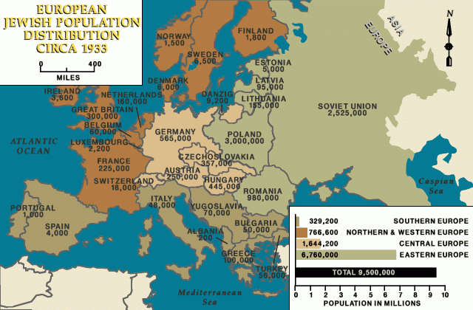
2.https://encyclopedia.ushmm.org/content/en/photo/anti-jewish-sign-in-bavaria
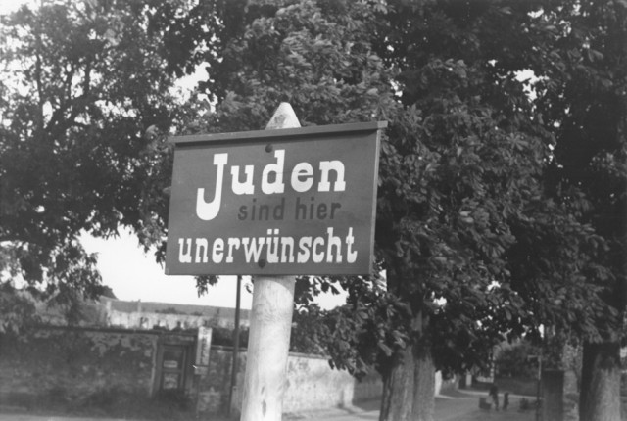

3. https://raillynews.com/2022/03/Today-in-history%2C-Hitler-gave-orders-to-boycott-Jews-and-Jewish-stores./

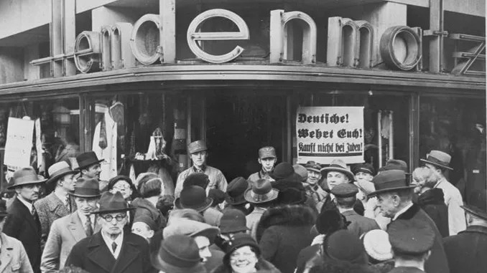

4. https://www.jewishvirtuallibrary.org/jewish-emigration-from-germany-1933-1939
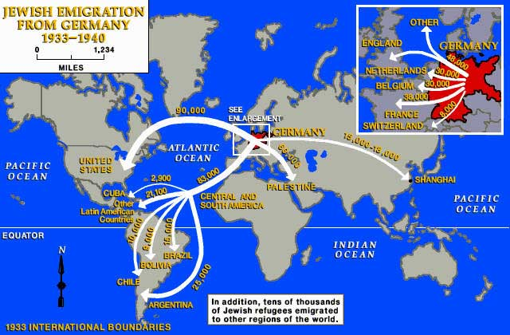

5.https://encyclopedia.ushmm.org/images/large/47613833-b331-41ca-b0da-771c2008323f.gif

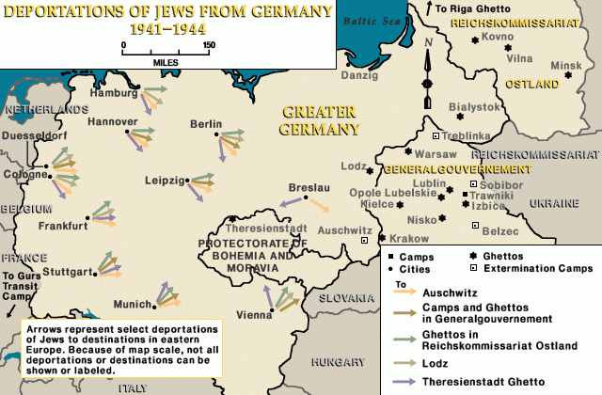

6.https://encyclopedia.ushmm.org/images/large/1df366c5-9c16-45e1-80a3-db2090fb3f88.jpg.pagespeed.ce.cVSukZ6BFk.jpg

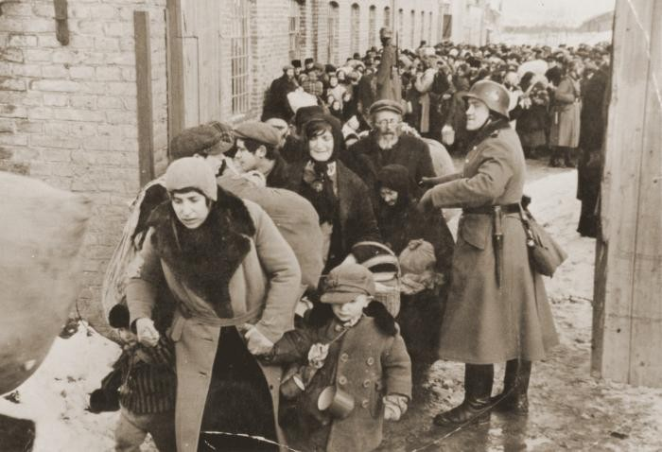

7.https://encyclopedia.ushmm.org/images/large/94820267-20ca-4726-a90b-6abe63ac3419.gif.pagespeed.ce.y5dBhzeVKH.gif
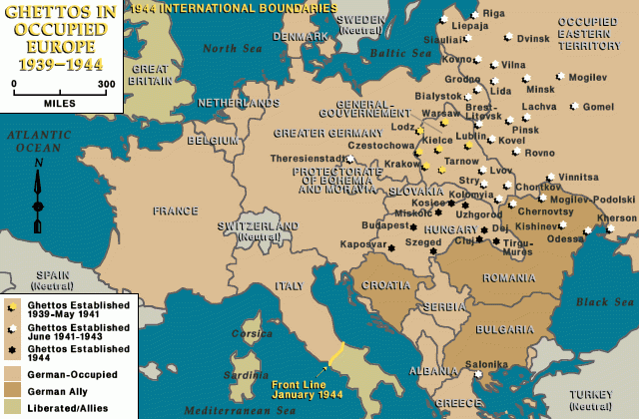
8. https://collections.ushmm.org/iiif-b/assets/783726
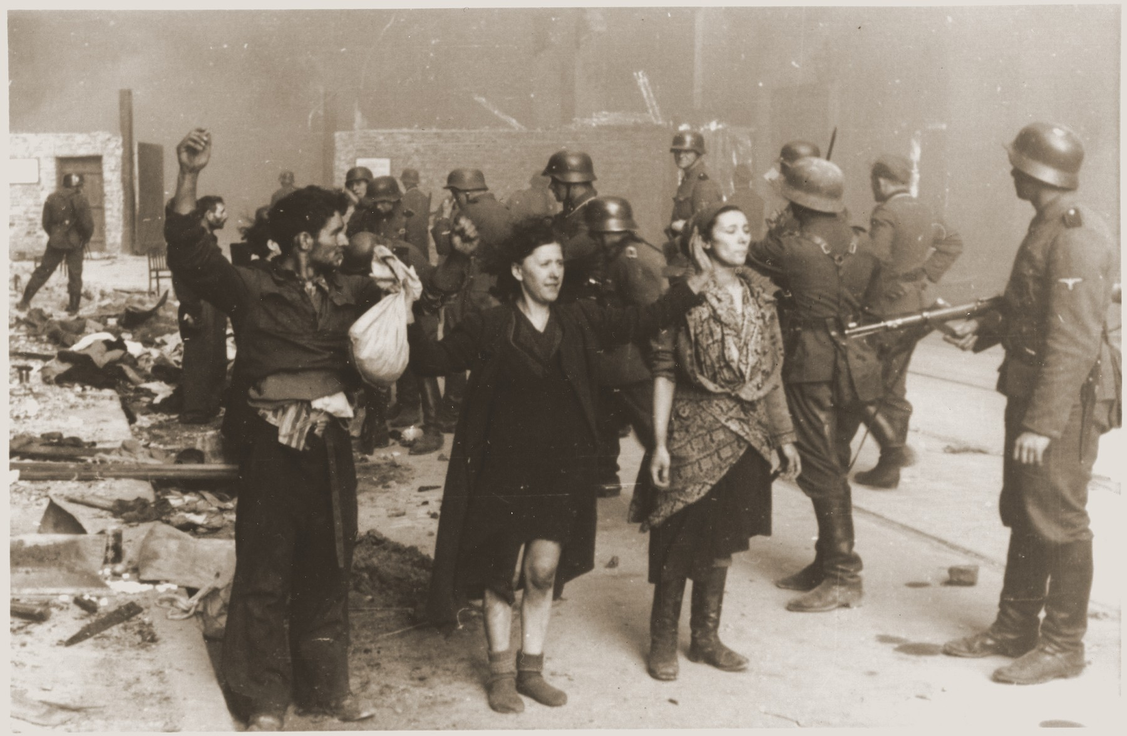

9..https://www.yadvashem.org/sites/default/files/styles/main_image_1block/public/4_58.JPG?itok=AsBiMQz3

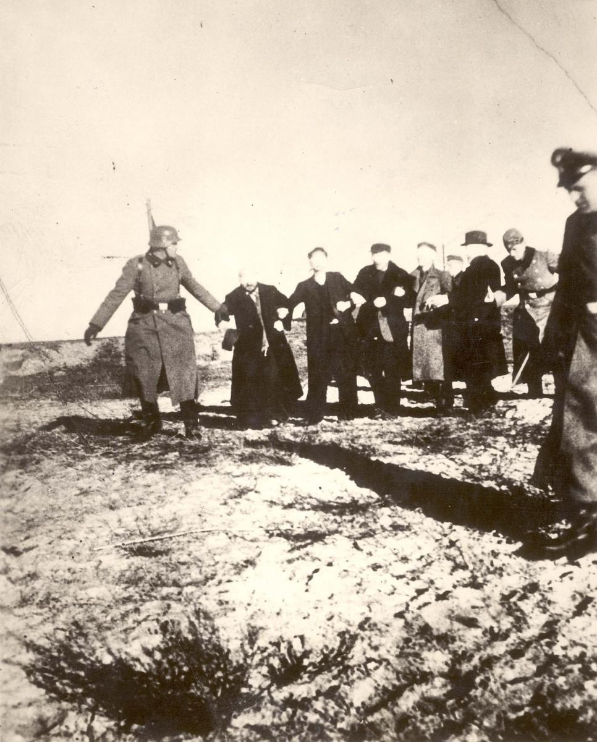

10.https://www.worldmap1.com/europe-map-second-world-war-1941-1942
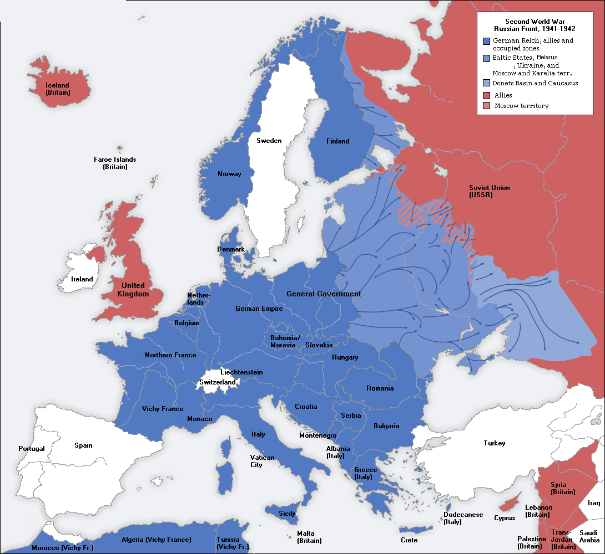

BIBLIOGRAPHY

- Antisemitism
https://encyclopedia.ushmm.org/content/en/article/antisemitism

- Early persecution and Anti-Jewish laws
Today in History: Hitler Orders a Boycott of Jews and Jewish-Owned Stores
https://encyclopedia.ushmm.org/content/en/oral-history/hanne-hirsch-liebmann-describes-harassment-and-anti-jewish-sentiment-in-germany?parent=en%2F102

https://jewishmuseum.org.uk/wp-content/uploads/2017/10/Anti-Jewish-Laws-in-Germany.pdf

“Kristallnacht” (Night of Broken Glass)
https://www.britannica.com/video/180224/Overview-Kristallnacht-10-1938

- Jewish emigration 1933 - 1940
https://www.jewishvirtuallibrary.org/jewish-emigration-from-germany-1933-1939

- Operation Barbarossa
https://www.ushmm.org/learn/timeline-of-events/1939-1941/operation-barbarossa

- Final solution: overview
https://encyclopedia.ushmm.org/content/en/article/final-solution-overview

- The beginning of the final solution
https://www.yadvashem.org/holocaust/about/final-solution-beginning.html

- The development of the final solution
https://www.yadvashem.org/education/educational-videos/video-toolbox/hevt-final-solution.html

- Madagascar Plan
https://www.yadvashem.org/odot_pdf/Microsoft%20Word%20-%206635.pdf

- Nisko and Lublin Plan
https://www.yadvashem.org/odot_pdf/Microsoft%20Word%20-%205965.pdf
- Forced Labor
https://encyclopedia.ushmm.org/content/en/article/forced-labor-an-overview

https://www.yadvashem.org/odot_pdf/Microsoft%20Word%20-%206625.pdf

- Ghettoization
https://encyclopedia.ushmm.org/content/en/article/ghettos

